JPL Rover – Connection Diagram

Version 1.0 – 22 October 2018

**KEY**

Power/serial from control board to RoboClaw

*x1 per Roboclaw = 5 total*

Power from control board to RoboClaw

*x1 per Roboclaw = 5 total*

Encoder Power/serial to drive motors

*x2 per Roboclaws 1-3 = 6 total*

Power to drive motors

*x2 per Roboclaws 1-3 = 6 total*

Power/data to steering encoders

*x2 per Roboclaws 4-5 = 4 total*

Power to steering motors

*x2 per Roboclaws 4-5 = 4 total*

**\*\* Pay close attention to the colours and orientation of**

**connectors/wires in the diagrams, they can change from**

**unit to unit!**

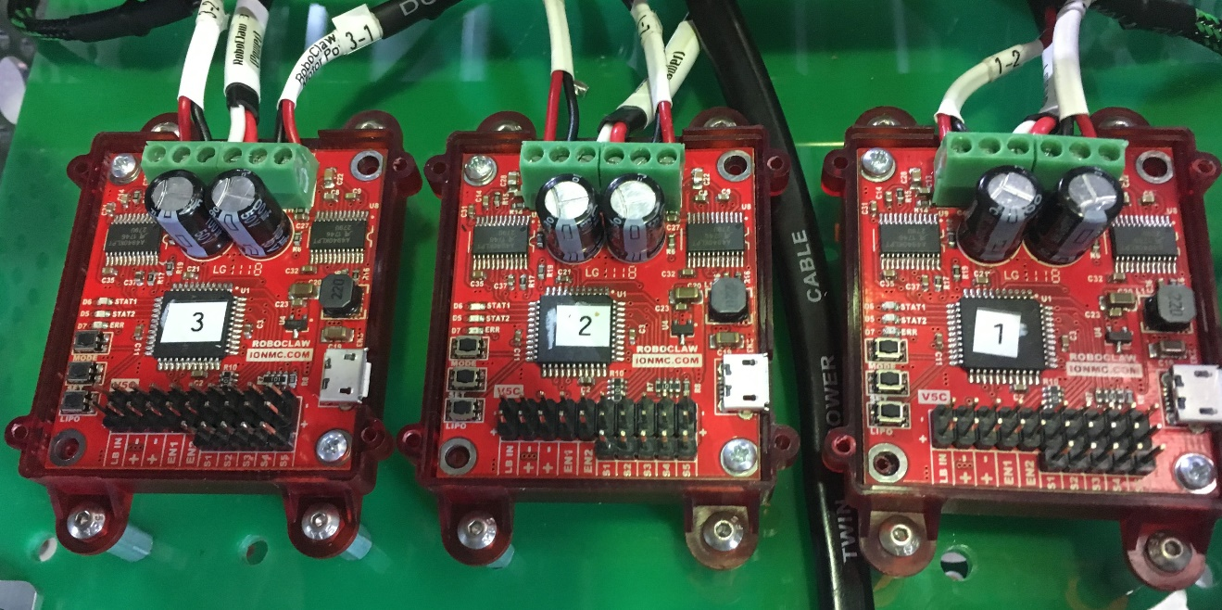

Logic Power (1)

1-1

Serial (1)

1-2

1-1

1-2

1-1 Motor Power

1-2 Motor Power

1 Power

RoboClaw 1

Logic Power (2)

2-1

Serial (2)

2-2

2-1

2-2

2-1 Motor Power

2-2 Motor Power

2 Power

RoboClaw 2

Logic Power (3)

3-1

Serial (3)

3-2

3-1

3-2

3-1 Motor Power

3-2 Motor Power

3 Power

RoboClaw 3

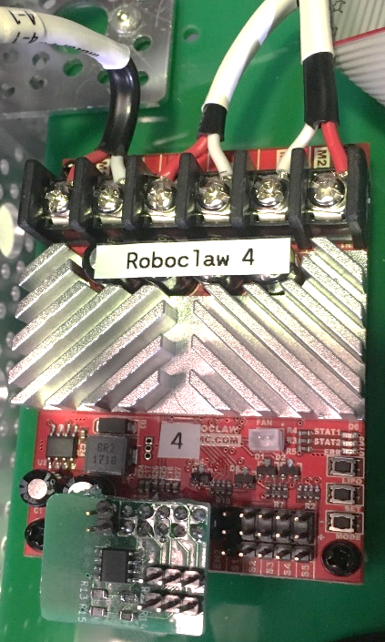

Logic Power (4)

Serial (4)

Encoder 4-1

Encoder 4-2

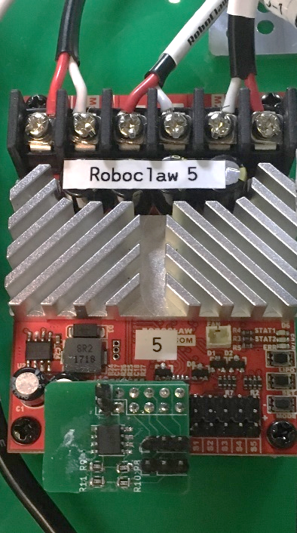

Encoder 5-2

Encoder 5-1

Logic Power (5)

Serial (5)

4-2 Motor Power

4-1 Motor Power

4 Power

5-2 Motor Power

5-1 Motor Power

5 Power

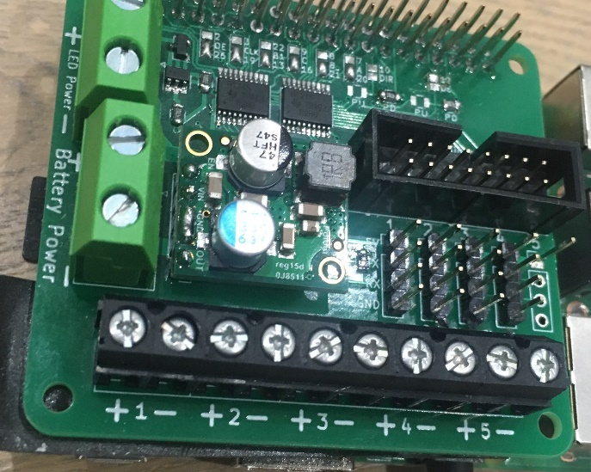

(1)

(2)

(3)

(4)

(5)

To LED Screen INPUT

To LED Screen

POWER

From Battery

(1)

(2)

(3)

(4)

(5)